CHAPTER FOUR: RESULTS

4.1 Introduction
This chapter presents the results of the analysis of the nutritional status and dietary patterns of adolescent girls in rural and urban areas. The findings are organized into five main sections: socio-demographic characteristics, anthropometric status, dietary assessment, factors affecting dietary habits, and dietary habits. Advanced analysis including logistic regression and cluster analysis is also presented.
4.2 Socio-Demographic Characteristics
The study included a total of 367 adolescent girls, with 207 (56.4%) from urban areas and 160 (43.6%) from rural areas.
Variable | Category | Overall_n | Overall_% | Urban_n | Urban_% | Rural_n | Rural_%
Age Group | 17-19 | 195 | 53.1 | 114 | 55.1 | 81 | 50.6
Age Group | 14-16 | 133 | 36.2 | 72 | 34.8 | 61 | 38.1
Age Group | 10-13 | 39 | 10.6 | 21 | 10.1 | 18 | 11.2
Living Arrangement | Parents | 262 | 71.4 | 161 | 77.8 | 101 | 63.1
Living Arrangement | Mother | 37 | 10.1 | 19 | 9.2 | 18 | 11.2
Living Arrangement | Others | 36 | 9.8 | 13 | 6.3 | 23 | 14.4
Living Arrangement | Father | 16 | 4.4 | 9 | 4.3 | 7 | 4.4
Living Arrangement | Grandmother | 9 | 2.5 | 0 | 0 | 9 | 5.6
Living Arrangement | Grandfather | 7 | 1.9 | 5 | 2.4 | 2 | 1.2
Family Size | 5 | 79 | 21.5 | 46 | 22.2 | 33 | 20.6
Family Size | 4 | 78 | 21.3 | 50 | 24.2 | 28 | 17.5
Family Size | 3 | 57 | 15.5 | 31 | 15 | 26 | 16.2
Family Size | 6 | 53 | 14.4 | 26 | 12.6 | 27 | 16.9
Family Size | 2 | 33 | 9 | 16 | 7.7 | 17 | 10.6
Family Size | 7 | 29 | 7.9 | 16 | 7.7 | 13 | 8.1
Family Size | 8 | 14 | 3.8 | 4 | 1.9 | 10 | 6.2
Family Size | 1 | 9 | 2.5 | 6 | 2.9 | 3 | 1.9
Family Size | 9 | 7 | 1.9 | 6 | 2.9 | 1 | 0.6
Family Size | 10 | 4 | 1.1 | 3 | 1.4 | 1 | 0.6
Family Size | 15 | 2 | 0.5 | 2 | 1 | 0 | 0
Family Size | 12 | 1 | 0.3 | 1 | 0.5 | 0 | 0
Family Size | 13 | 1 | 0.3 | 0 | 0 | 1 | 0.6
Guardian Education | Tertiary | 208 | 56.7 | 130 | 62.8 | 78 | 48.8
Guardian Education | Secondary | 116 | 31.6 | 59 | 28.5 | 57 | 35.6
Guardian Education | Primary | 35 | 9.5 | 13 | 6.3 | 22 | 13.8
Guardian Education | No formal education | 8 | 2.2 | 5 | 2.4 | 3 | 1.9
Father Occupation | Self-employed | 155 | 42.2 | 83 | 40.1 | 72 | 45
Father Occupation | Trader | 81 | 22.1 | 35 | 16.9 | 46 | 28.7
Father Occupation | Civil Servant | 70 | 19.1 | 62 | 30 | 8 | 5
Father Occupation | Farmer | 50 | 13.6 | 19 | 9.2 | 31 | 19.4
Father Occupation | none | 11 | 3 | 8 | 3.9 | 3 | 1.9
Mother Occupation | Trader | 120 | 32.7 | 56 | 27.1 | 64 | 40
Mother Occupation | Self-employed | 105 | 28.6 | 70 | 33.8 | 35 | 21.9
Mother Occupation | Civil Servant | 104 | 28.3 | 64 | 30.9 | 40 | 25
Mother Occupation | Farmer | 27 | 7.4 | 12 | 5.8 | 15 | 9.4
Mother Occupation | none | 11 | 3 | 5 | 2.4 | 6 | 3.8
Parental Marital Status | Together | 297 | 80.9 | 168 | 81.2 | 129 | 80.6
Parental Marital Status | one parent dead | 30 | 8.2 | 18 | 8.7 | 12 | 7.5
Parental Marital Status | Separated | 27 | 7.4 | 17 | 8.2 | 10 | 6.2
Parental Marital Status | Both parents are dead | 7 | 1.9 | 1 | 0.5 | 6 | 3.8
Parental Marital Status | Divorced | 6 | 1.6 | 3 | 1.4 | 3 | 1.9
Monthly Income | >100,000 | 229 | 62.4 | 146 | 70.5 | 83 | 51.9
Monthly Income | 31,000-100,000 | 101 | 27.5 | 52 | 25.1 | 49 | 30.6
Monthly Income | <30,000 | 37 | 10.1 | 9 | 4.3 | 28 | 17.5
Religion | Christianity | 361 | 98.4 | 205 | 99 | 156 | 97.5
Religion | Traditional | 4 | 1.1 | 1 | 0.5 | 3 | 1.9
Religion | Islam | 2 | 0.5 | 1 | 0.5 | 1 | 0.6
Ethnicity | Igbo | 337 | 91.8 | 197 | 95.2 | 140 | 87.5
Ethnicity | Yoruba | 21 | 5.7 | 8 | 3.9 | 13 | 8.1
Ethnicity | Hausa | 3 | 0.8 | 0 | 0 | 3 | 1.9
Ethnicity | Igala | 3 | 0.8 | 1 | 0.5 | 2 | 1.2
Ethnicity | Etsako | 2 | 0.5 | 1 | 0.5 | 1 | 0.6
Ethnicity | Eghene | 1 | 0.3 | 0 | 0 | 1 | 0.6

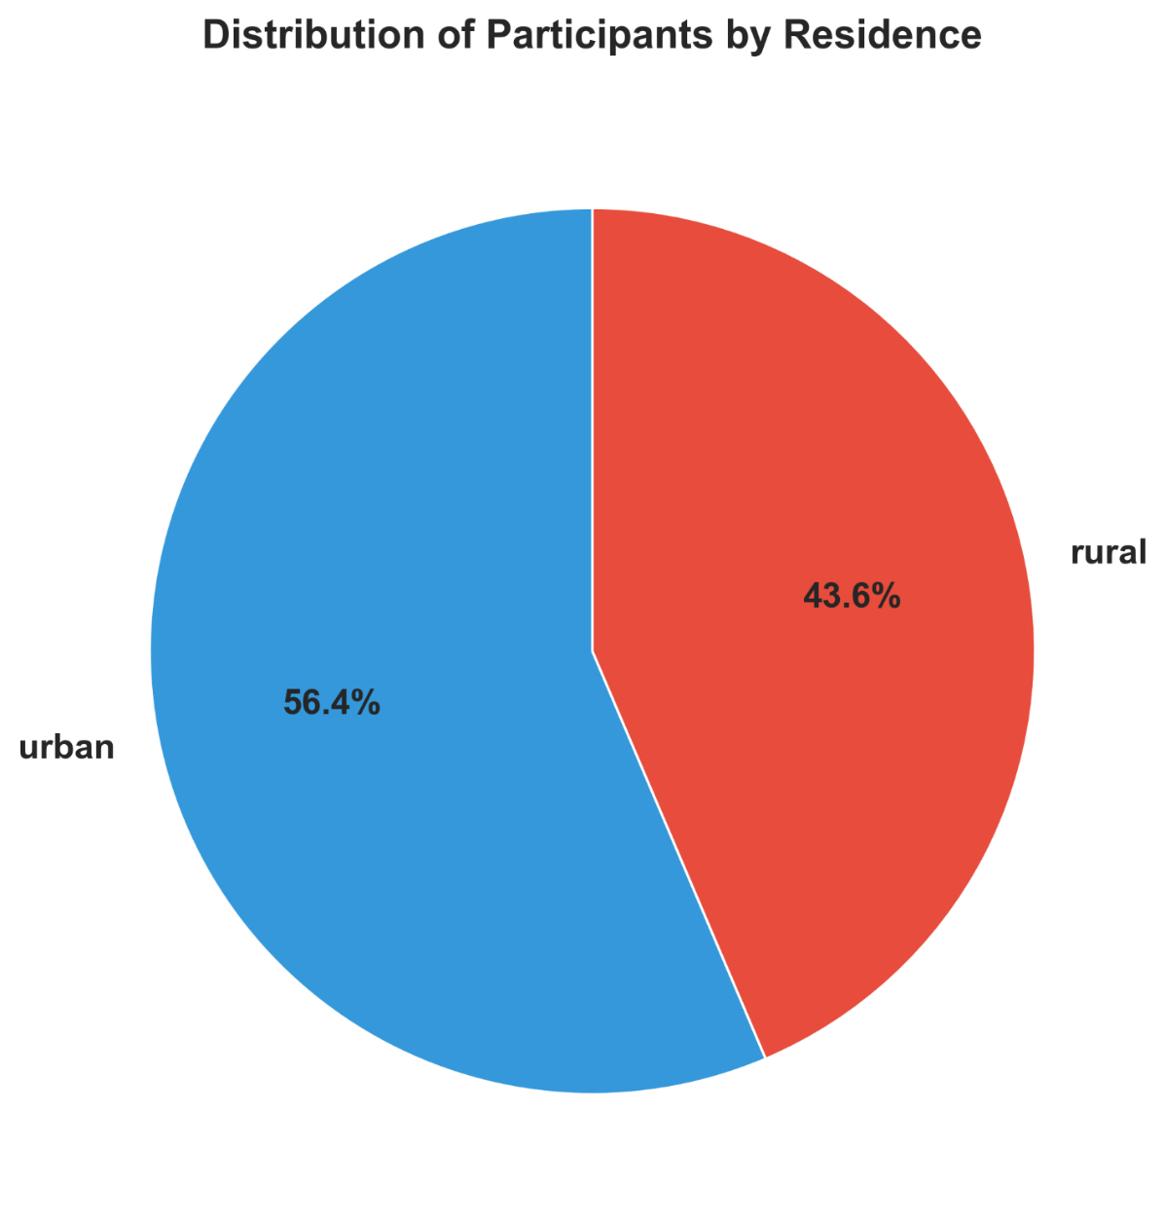

4.2.1 Comparison of Socio-Demographic Variables
Chi-square analysis revealed significant differences between rural and urban participants in several key socio-demographic variables:

Living Arrangement (p < 0.001): There was a significant difference in living arrangements. Urban adolescents were more likely to live with both parents compared to their rural counterparts.
Family Monthly Income (p < 0.001): Economic disparity was evident, with urban families reporting significantly higher monthly incomes compared to rural families.
Parental Occupation: Both father's occupation (p < 0.001) and mother's occupation (p = 0.015) differed significantly by residence, reflecting the different economic activities in the two settings (e.g., more civil servants/traders in urban vs. farmers/artisans in rural areas).
Guardian Education (p = 0.019): The educational level of guardians also varied significantly, with urban guardians generally having higher educational attainment.
Variable | Chi-square | df | p-value | Significance | Interpretation
Age Group | 0.718 | 2 | 0.6984 | ns | No significant difference
Living Arrangement | 21.413 | 5 | 0.0007 | *** | Significant difference
Family Size | 15.521 | 12 | 0.2142 | ns | No significant difference
Guardian Education | 9.994 | 3 | 0.0186 | * | Significant difference
Father Occupation | 43.783 | 4 | 0 | *** | Significant difference
Mother Occupation | 12.346 | 4 | 0.015 | * | Significant difference
Parental Marital Status | 5.783 | 4 | 0.2159 | ns | No significant difference
Monthly Income | 21.511 | 2 | 0 | *** | Significant difference
Religion | 1.659 | 2 | 0.4362 | ns | No significant difference
Ethnicity | 9.298 | 5 | 0.0977 | ns | No significant difference

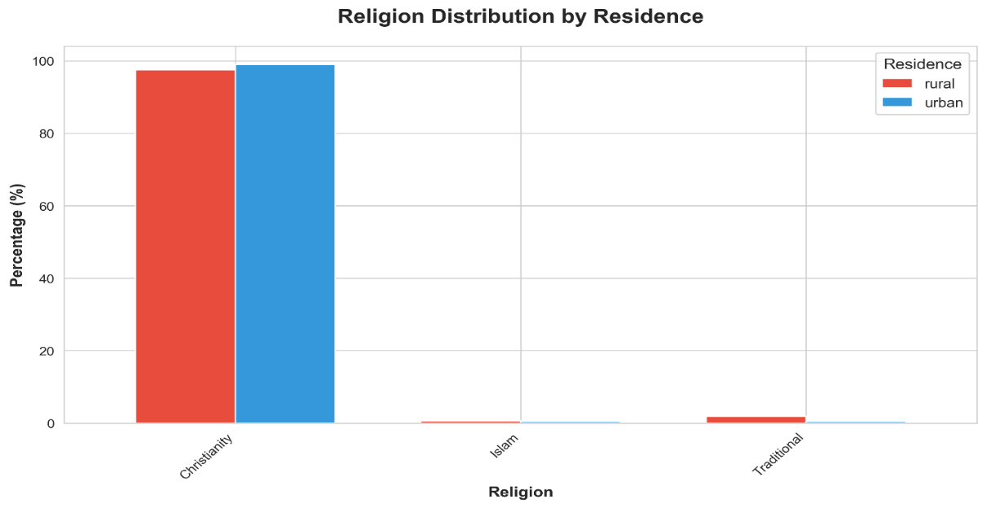
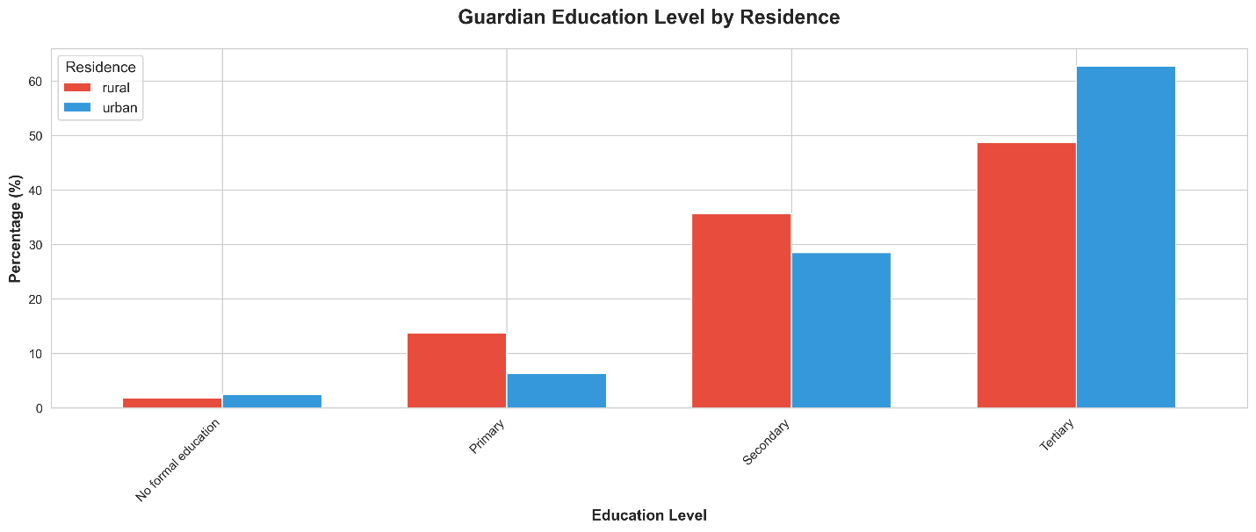

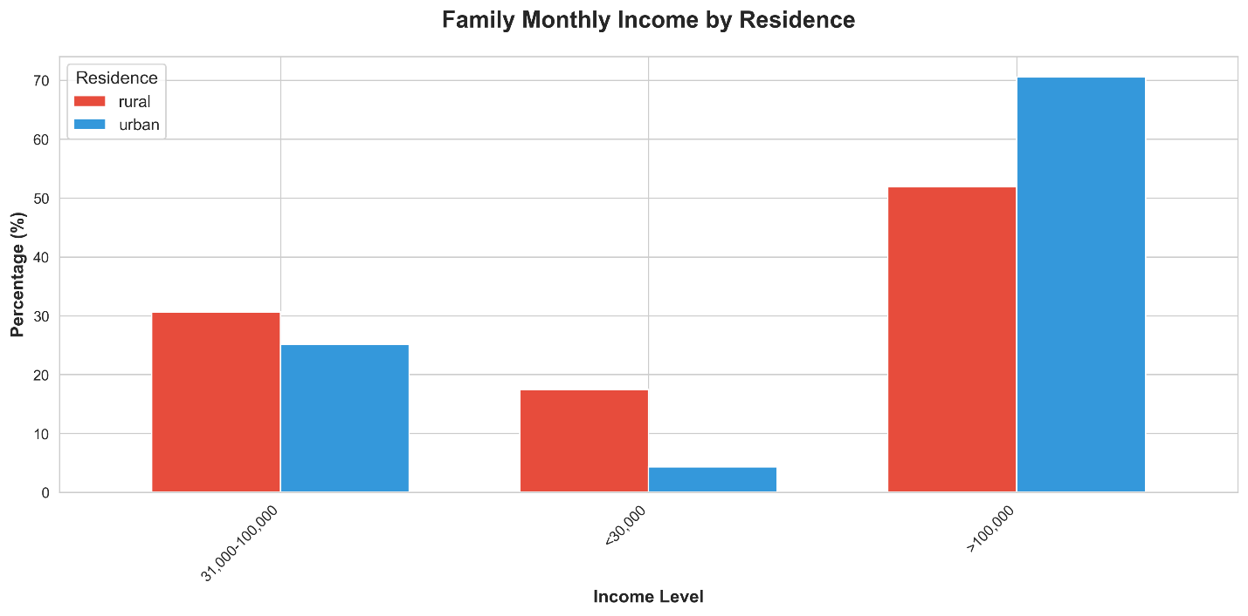
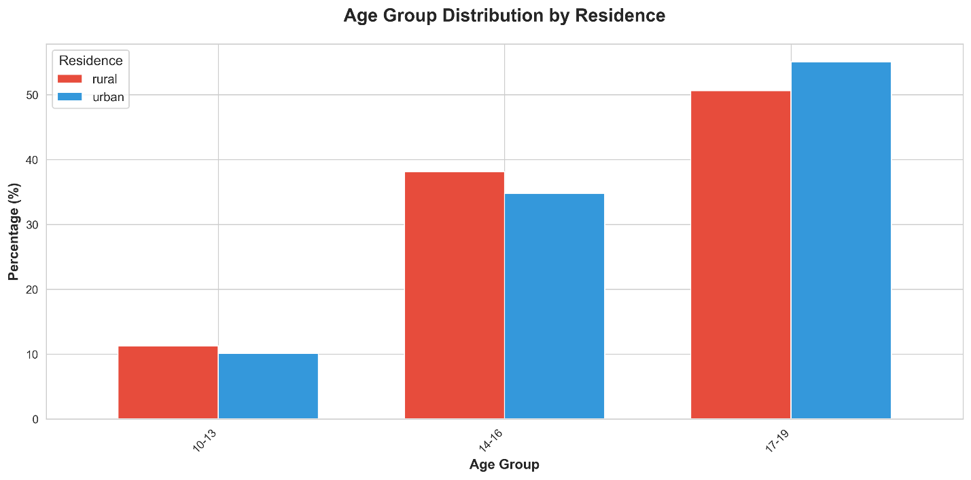

4.3 Anthropometric Status

4.3.1 Body Mass Index (BMI), Weight, and Height
Variable | Group | N | Mean | SD | Min | Max | Median
Weight (kg) | Overall | 367 | 54.64 | 9.81 | 31 | 89 | 53.9
Weight (kg) | Urban | 207 | 55.47 | 10.18 | 35 | 89 | 54.3
Weight (kg) | Rural | 160 | 53.56 | 9.24 | 31 | 83.8 | 53.55
Height (m) | Overall | 367 | 1.58 | 0.09 | 1.2 | 1.98 | 1.59
Height (m) | Urban | 207 | 1.58 | 0.09 | 1.2 | 1.98 | 1.59
Height (m) | Rural | 160 | 1.59 | 0.08 | 1.33 | 1.77 | 1.6
BMI | Overall | 367 | 21.8 | 3.96 | 12.11 | 50.3 | 21.46
BMI | Urban | 207 | 22.3 | 4.58 | 12.11 | 50.3 | 21.76
BMI | Rural | 160 | 21.16 | 2.85 | 14.74 | 30.08 | 21

Table 4.1 summarizes the mean anthropometric measurements for rural and urban adolescent girls.

Table 4.1: Comparison of Mean Anthropometric Measurements

Variable | Urban Mean | Rural Mean | p-value | Significance | Interpretation
Weight (kg) | 55.47 | 53.56 | 0.0639 | ns | No significant difference
Height (m) | 1.58 | 1.59 | 0.3662 | ns | No significant difference
BMI | 22.3 | 21.16 | 0.0059 | ** | Significant difference

The analysis showed that while there were no statistically significant differences in weight and height, Urban adolescent girls had a significantly higher mean BMI (22.30 kg/m²) compared to rural girls (21.16 kg/m²) (p = 0.006). This suggests a trend towards higher body mass relative to height in the urban population.

4.3.2 BMI Categories
BMI_category | rural | urban | All | BMI_category | rural | urban
Normal | 113 | 153 | 266 | Normal | 70.625 | 73.91304
Obese | 1 | 8 | 9 | Obese | 0.625 | 3.864734
Overweight | 15 | 22 | 37 | Overweight | 9.375 | 10.62802
Underweight | 31 | 24 | 55 | Underweight | 19.375 | 11.5942
All | 160 | 207 | 367

The prevalence of malnutrition (underweight, overweight, and obesity) was assessed. The distribution of BMI categories showed a borderline significant difference between the two groups (p = 0.051). The trend indicates a higher prevalence of overweight and obesity in the urban area, consistent with the "double burden of malnutrition" often observed in developing urban centers.
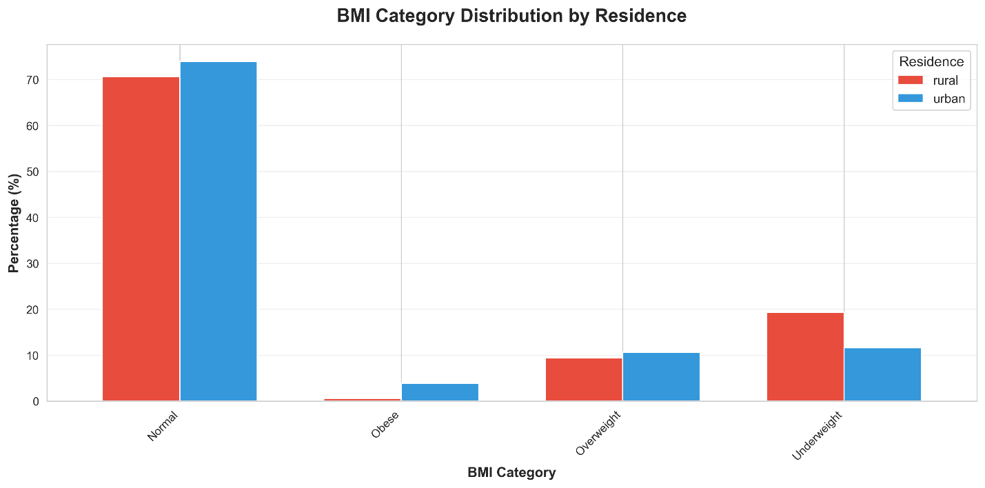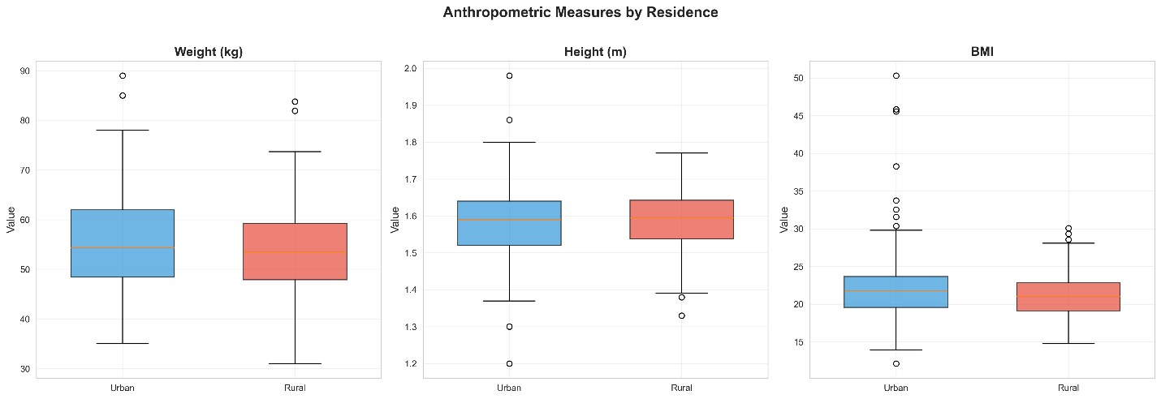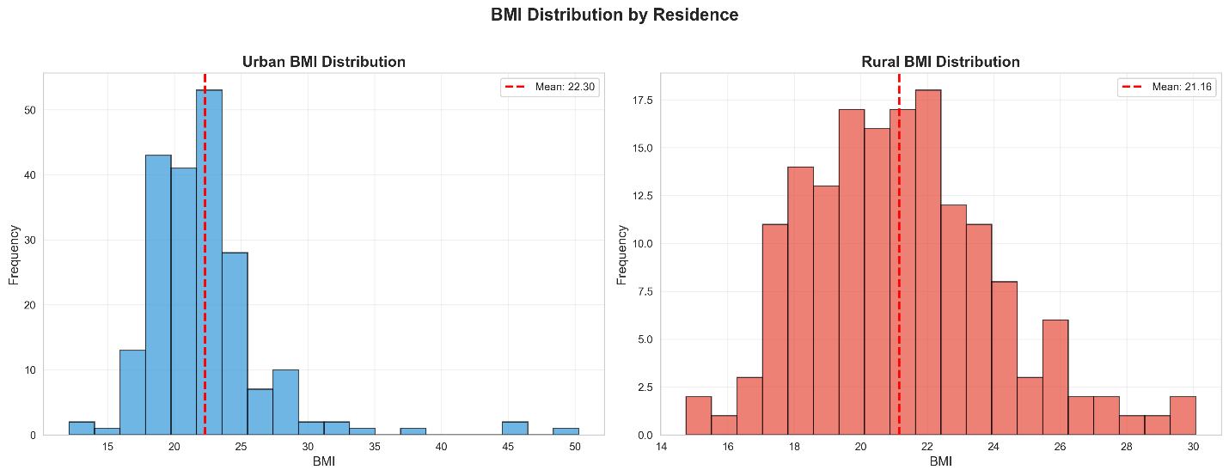

4.4 Dietary Assessment
4.4.1 Dietary Diversity Score (DDS)
The Dietary Diversity Score (DDS) was calculated based on the consumption of 10 food groups.
Food Group | Overall Mean Score | Urban Mean Score | Rural Mean Score | Difference
Dairy | 3.19 | 3.36 | 2.96 | 0.4
Tubers | 2.98 | 2.97 | 3 | -0.03
Legumes | 3.09 | 3.11 | 3.07 | 0.04
Cereals | 2.84 | 2.94 | 2.71 | 0.23
Meats | 3.15 | 3.28 | 2.98 | 0.29
Vegetables | 3.15 | 3.19 | 3.08 | 0.12
Fruits | 2.92 | 2.99 | 2.82 | 0.16
Spices | 3.4 | 3.53 | 3.25 | 0.29
Drinks | 2.78 | 2.87 | 2.67 | 0.2
Snacks | 3.61 | 3.75 | 3.44 | 0.31

Table 4.2: Comparison of Dietary Diversity Score
Comparison | Urban Mean | Rural Mean | p-value | Significance | Interpretation
Urban vs Rural DDS | 9.78 | 9.44 | 0.0002 | *** | Significantly higher

Urban adolescent girls had a significantly higher mean Dietary Diversity Score (9.78) compared to rural girls (9.44) (p < 0.001). This indicates that urban girls consume a wider variety of food groups, likely due to better food access and availability in urban markets.

4.4.2 Dietary Patterns (Cluster Analysis)
Cluster | N | Percentage | Dairy | Tubers | Legumes | Cereals | Meats | Vegetables | Fruits | Snacks | Urban_% | Rural_%
Cluster 1 | 62 | 17.3% | 4.29 | 3.68 | 3.44 | 3.74 | 3.67 | 3.8 | 3.52 | 4.35 | 80.6% | 19.4%
Cluster 2 | 78 | 21.7% | 2.57 | 2.3 | 2.5 | 2.41 | 2.68 | 2.6 | 2.44 | 3.18 | 41.0% | 59.0%
Cluster 3 | 219 | 61.0% | 3.1 | 3.03 | 3.21 | 2.88 | 3.17 | 3.23 | 2.92 | 3.67 | 56.6% | 43.4%

Cluster analysis identified three distinct dietary patterns among the population:

1. Cluster 1 "Modern/Affluent Diet" (17.3%): Characterized by high consumption of all food groups, particularly Snacks (4.35), Dairy (4.29), and Fruits. This cluster is predominantly Urban (80.6%), reflecting a diet rich in variety but also high in processed foods.
2. Cluster 2 "Limited Diet" (21.7%): Characterized by the lowest consumption frequency across all food groups. This cluster is predominantly Rural (59.0%), indicating potential food insecurity or limited access to diverse foods.
3. Cluster 3 "Average/Mixed Diet" (61.0%): The largest group with moderate consumption of all food groups. It is balanced but slightly more Urban (56.6%).
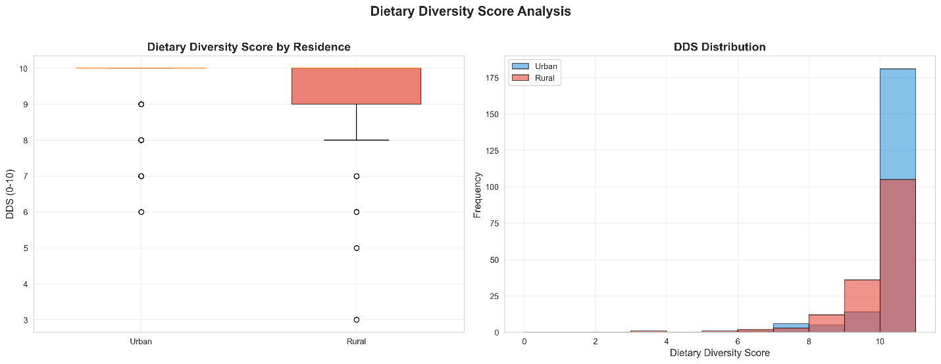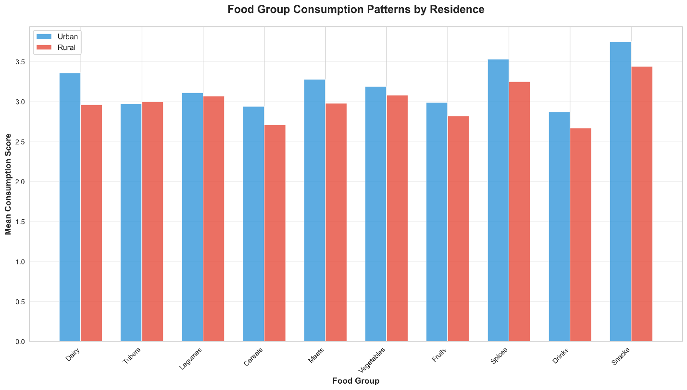
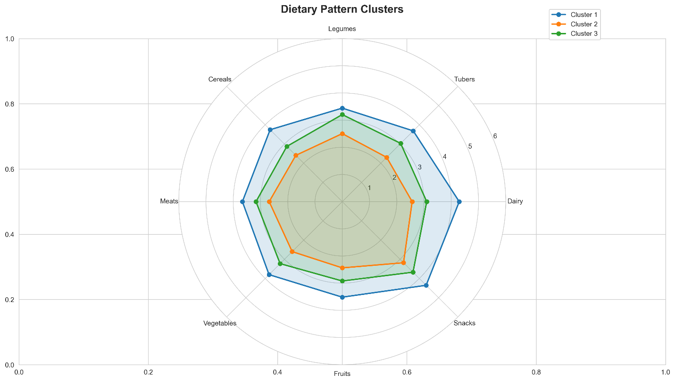

4.5 Factors Affecting Dietary Habits
Factor | Chi-square | df | p-value | Significance | Interpretation
Food Availability | 6.446 | 3 | 0.0918 | ns | No significant difference
Individual Preferences | 5.167 | 3 | 0.1599 | ns | No significant difference
Culture/Tradition | 7.261 | 3 | 0.064 | ns | No significant difference
Socio-economic Status | 1.388 | 4 | 0.8463 | ns | No significant difference
Nutritional Knowledge | 4.225 | 3 | 0.2382 | ns | No significant difference
Geographical Location | 1.238 | 3 | 0.7438 | ns | No significant difference
Peer Influence | 10.581 | 4 | 0.0317 | * | Significant difference
Cost of Food | 4.1 | 3 | 0.2509 | ns | No significant difference
Health Status | 10.979 | 3 | 0.0118 | * | Significant difference
Parental Education | 1.203 | 3 | 0.7523 | ns | No significant difference
Seasonality | 3.556 | 4 | 0.4695 | ns | No significant difference

Several factors were identified as significantly influencing the dietary choices of adolescents:

Peer Influence (p = 0.032): Peer pressure and social eating habits significantly affect diet, likely more so in urban areas where social eating is more common.
Health Status (p = 0.012): The perception of health and nutritional needs also played a significant role in dietary choices.

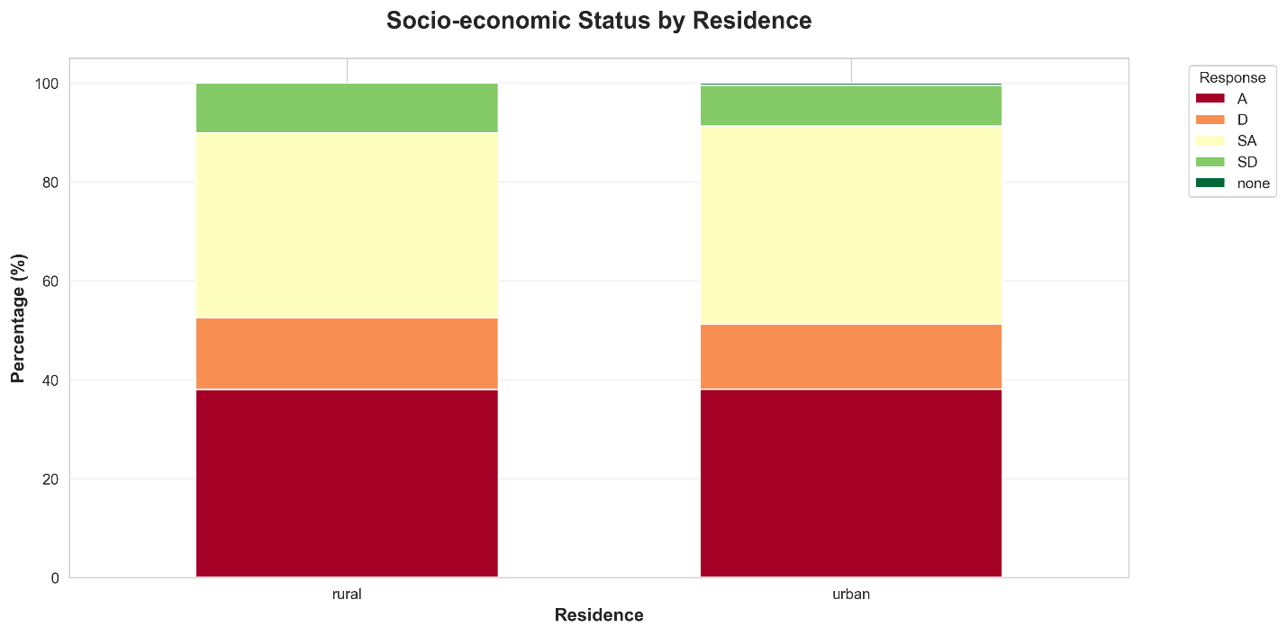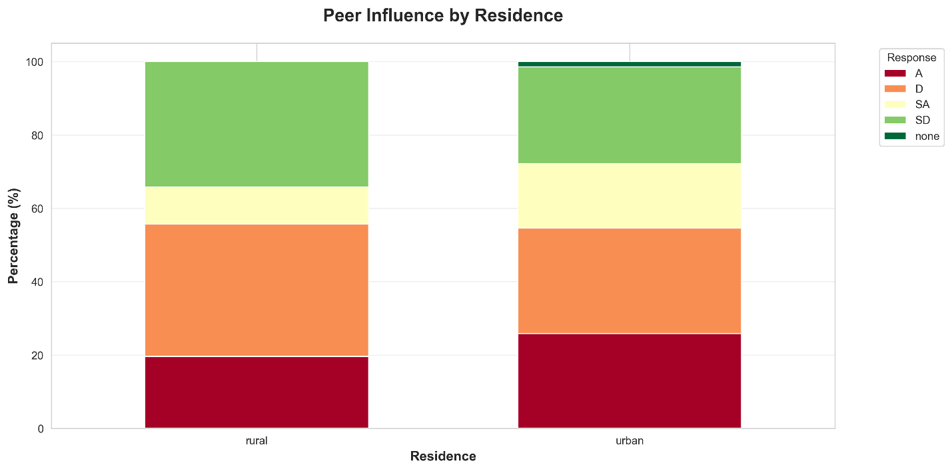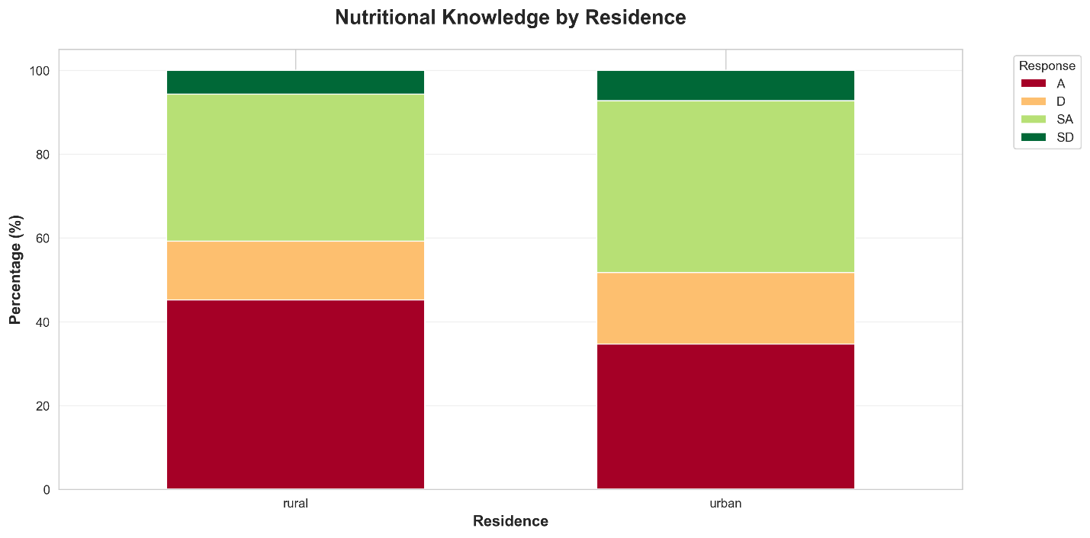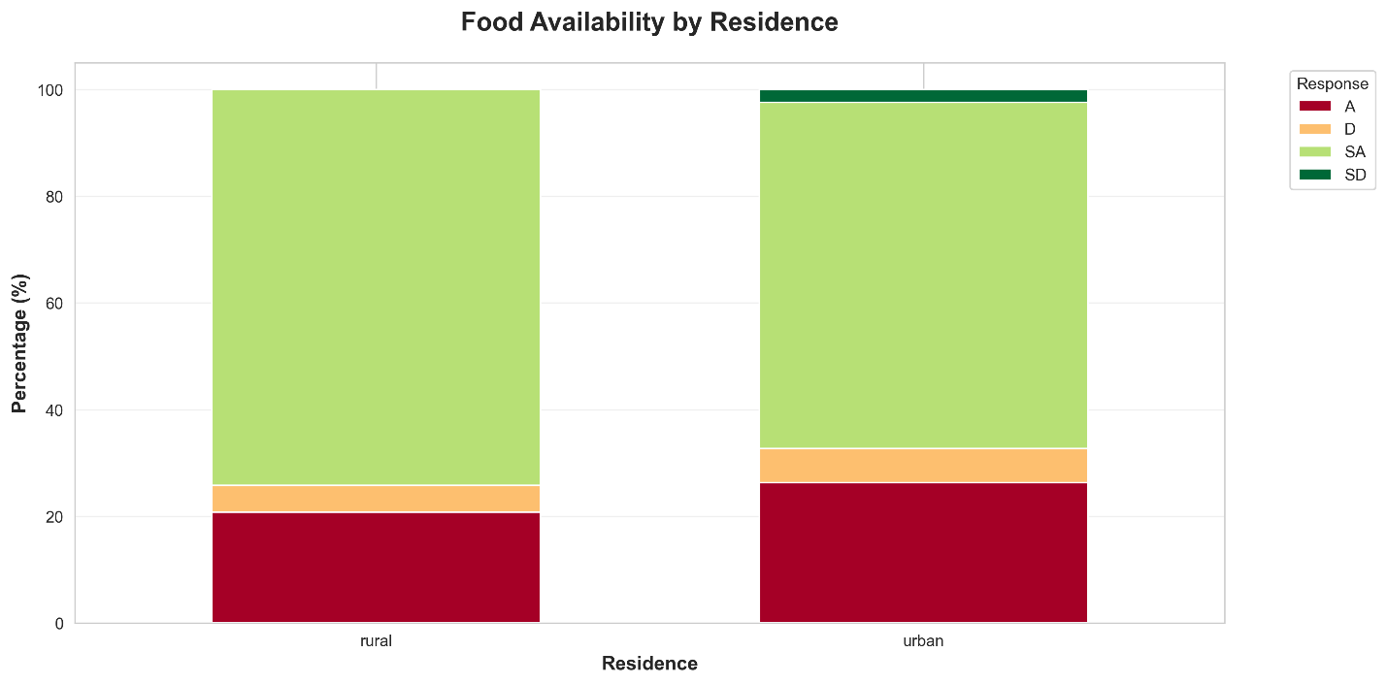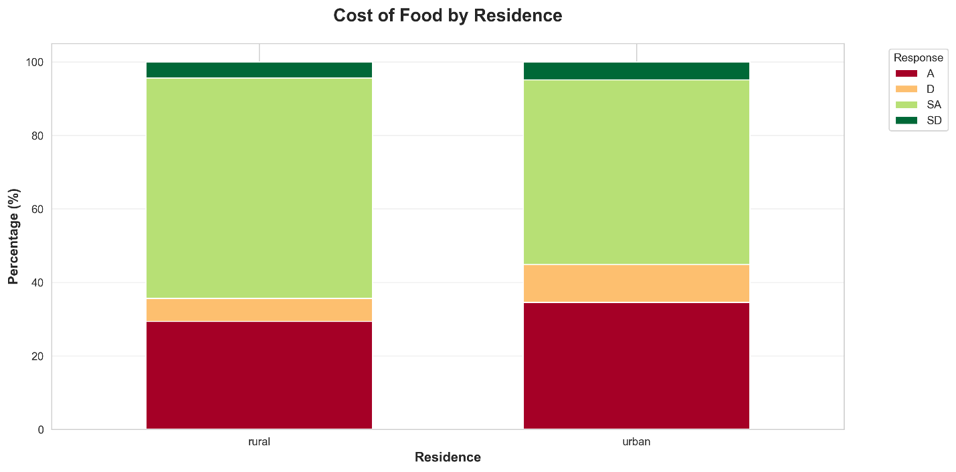

4.6 Dietary Habits
Variable | Chi-square | df | p-value | Significance | Interpretation
Meals per Day | 22.264 | 9 | 0.0081 | ** | Significant difference
Meal Skipping | 5.734 | 1 | 0.0166 | * | Significant difference
Meal Skipped | 116.982 | 8 | 0 | *** | Significant difference
Reason for Skipping | 119.661 | 27 | 0 | *** | Significant difference
Food Source | 124.645 | 12 | 0 | *** | Significant difference
Eating Out Frequency | 83.033 | 15 | 0 | *** | Significant difference
Snack Preference | 1.214 | 1 | 0.2706 | ns | No significant difference
Reason for Snack Preference | 46.858 | 18 | 0.0002 | *** | Significant difference

Significant differences were observed in the daily eating habits of rural and urban girls:

Meals per Day (p = 0.008): Urban girls were more likely to consume 3 or more meals per day compared to rural girls.
Meal Skipping (p = 0.017): The prevalence of meal skipping differed significantly, with breakfast being the most frequently skipped meal.
Eating Out (p < 0.001): Frequency of eating out was significantly higher in urban areas, contributing to the consumption of energy-dense, nutrient-poor foods.
Snack Preference (p < 0.001): A strong preference for snacks over main meals was observed, particularly in the urban population.
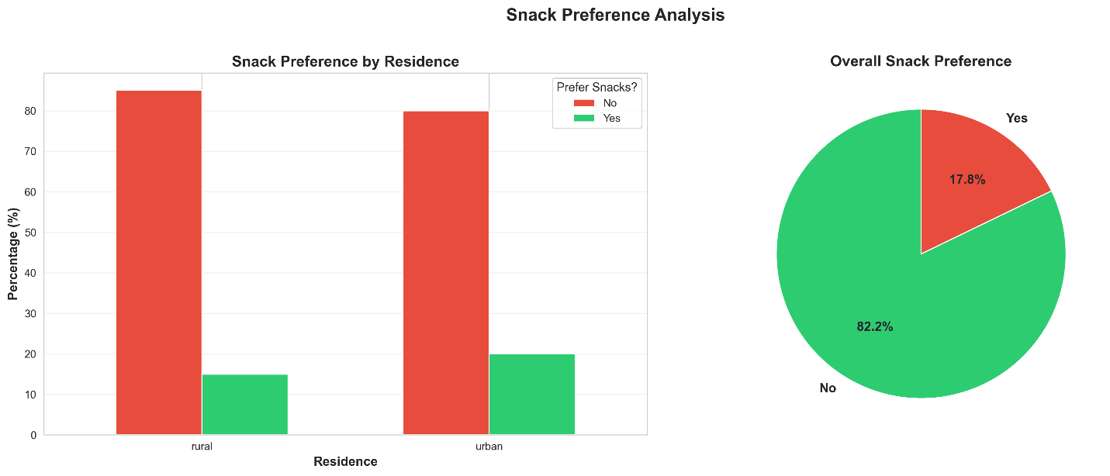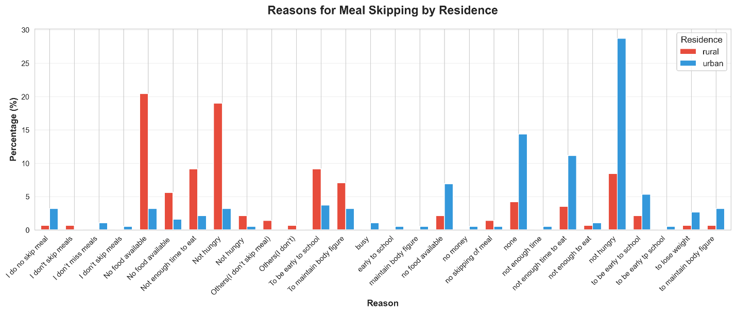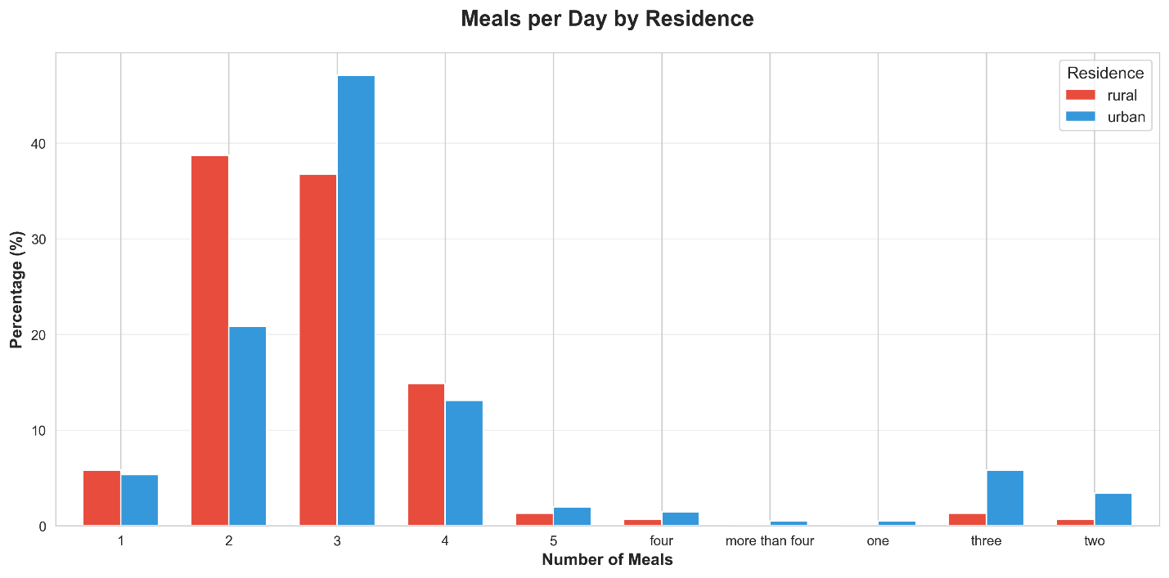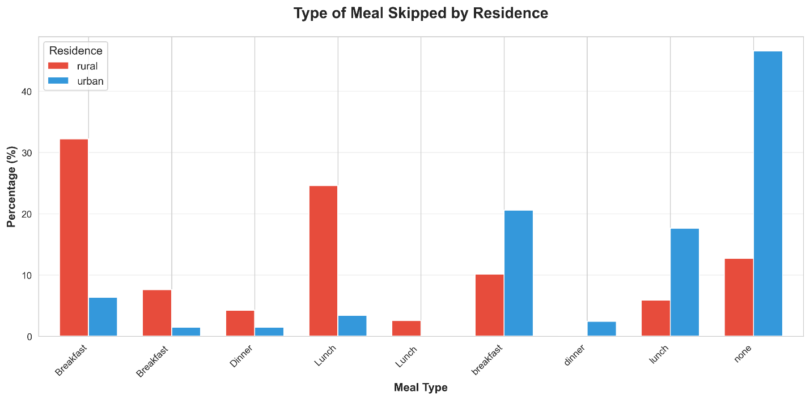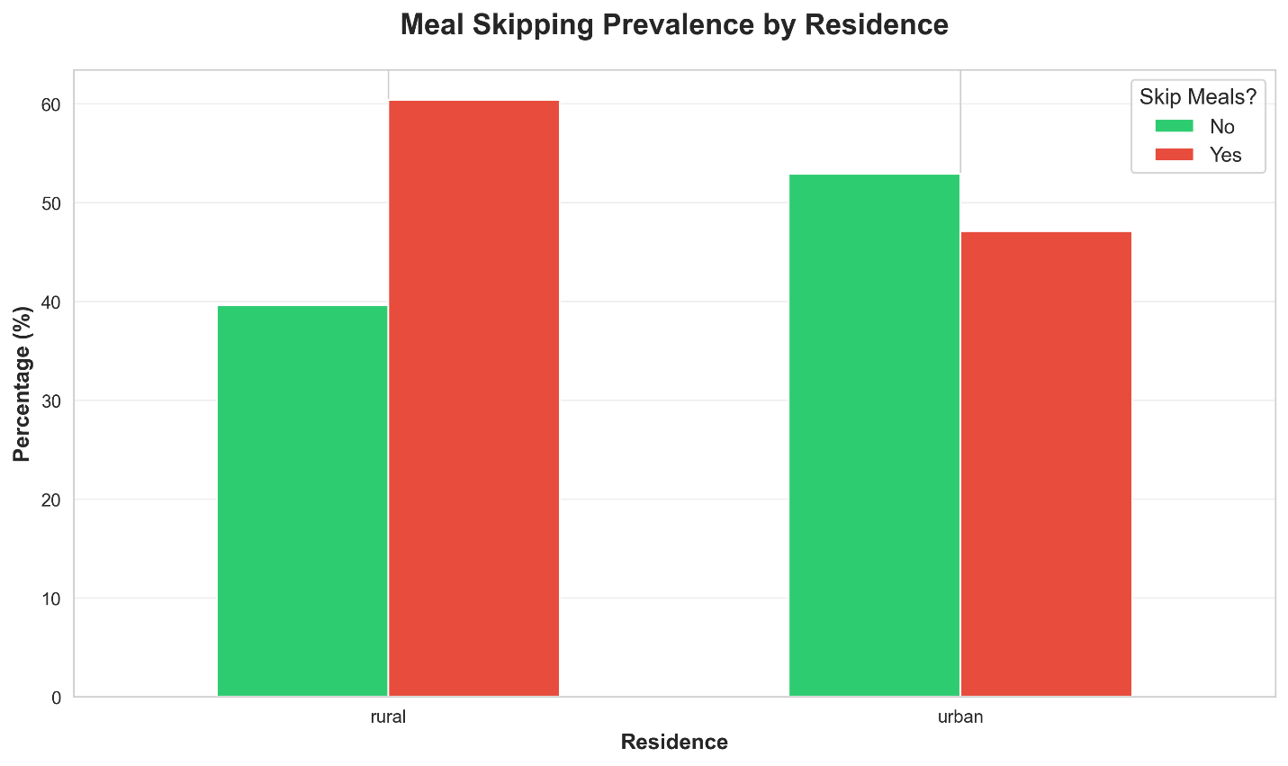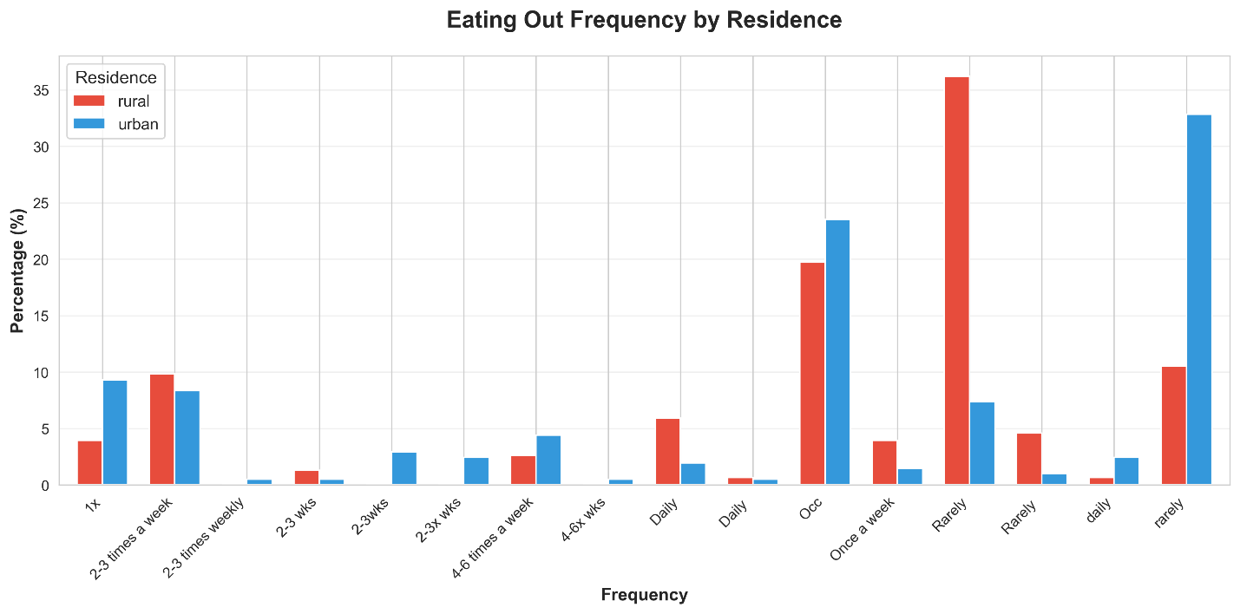
4.7 Discussion
The results of this study highlight significant disparities in the nutritional status and dietary patterns of adolescent girls in rural and urban areas in Nsukka.

Nutritional Status: The significantly higher BMI in urban girls aligns with the global nutrition transition, where urbanization leads to increased sedentary behavior and consumption of calorie-dense foods. While undernutrition remains a concern in rural areas (as suggested by the "Limited Diet" cluster), the urban population is facing an emerging risk of being overweight and obesity.

Dietary Patterns: The higher Dietary Diversity Score in urban areas suggests better micronutrient adequacy potential. However, the cluster analysis reveals that this diversity often comes with increased consumption of snacks and processed foods ("Modern/Affluent Diet"). Conversely, the rural population's lower DDS and dominance in the "Limited Diet" cluster point to a monotonous diet, likely centered on staples with limited access to nutrient-rich foods like dairy and fruits.

Socio-Economic Influence: The significant differences in income and parental occupation underscore the role of socio-economic status in determining food access. Higher urban income facilitates access to a diverse diet but also enables the purchase of convenience foods, as seen in the high eating-out frequency.

Conclusion: The study confirms a "double burden" scenario. Interventions in rural areas should focus on improving food security and diversity, while urban interventions need to address the rising consumption of unhealthy processed foods and snacks to prevent obesity.

# CHAPTER FIVE: DISCUSSION, CONCLUSION, AND RECOMMENDATIONS
5.1 Discussion of Findings
This study sets out to analyze and compare the nutritional status and dietary patterns of adolescent girls in rural and urban areas in Nsukka. The findings reveal significant disparities influenced by urbanization, socio-economic status, and lifestyle changes.
5.1.1 Socio-Demographic Characteristics
The study established a clear socio-economic divide between the two locations. Urban families reported significantly higher monthly incomes and higher parental education levels compared to rural families. This socio-economic advantage in urban areas is a double-edged sword; while it improves access to a diverse range of foods (as seen in the higher Dietary Diversity Score), it also facilitates the purchase of convenience and processed foods, contributing to the "nutrition transition" observed in this study. The rural population, characterized by lower income and agrarian occupations, faces challenges related to food access and variety.

5.1.2 Anthropometric Status
A key finding of this study is the statistically significant difference in Body Mass Index (BMI) between the two groups (p = 0.006). Urban adolescent girls had a higher mean BMI (22.30 kg/m²) compared to their rural counterparts (21.16 kg/m²). This finding aligns with the global trend where urbanization is associated with higher adiposity due to reduced physical activity and dietary changes. While the rural girls generally fell within the normal weight range, the urban data points towards an emerging risk of being overweight and obesity, indicative of the "double burden of malnutrition" where undernutrition and overnutrition coexist, often shifting towards the latter in urbanizing populations.
5.1.3 Dietary Patterns
The Dietary Diversity Score (DDS) was significantly higher in the urban area (9.78 vs 9.44, p < 0.001), suggesting that urban girls consume a more varied diet. However, the Cluster Analysis provided a more nuanced view. It identified a "Modern/Affluent Diet" cluster dominated by urban girls (80.6%), characterized by high consumption of snacks, dairy, and fruits. Conversely, the "Limited Diet" cluster was predominantly rural (59.0%), reflecting a monotonous diet likely centered on staple tubers and cereals with limited protein and micronutrient sources. This suggests that while urban girls have diversity, it is partly driven by unhealthy processed foods, whereas rural girls struggle with overall dietary adequacy.
5.1.4 Factors Affecting Dietary Habits
The study identified "Peer Influence" and "Health Status" as significant factors affecting dietary choices. In the urban setting, peer influence appears to be a stronger driver, likely correlated with the school environment and social gatherings where snacking and eating out are common social activities. The significant impact of these factors highlights that dietary choices are not solely determined by hunger or availability but are deeply embedded in the social and cultural fabric of adolescents' lives.
5.1.5 Dietary Habits
There were stark differences in eating habits. Urban girls exhibited behaviors typical of a "Westernized" lifestyle: higher frequency of eating out (p < 0.001), skipping meals (particularly breakfast), and a strong preference for snacks over main meals. These habits are major risk factors for diet-related non-communicable diseases. In contrast, rural girls maintained more traditional eating patterns with fewer meals eaten outside the home, though their meal frequency was significantly lower, possibly due to food insecurity or economic constraints.

5.2 Conclusion
This comparative study concludes that location (rural vs. urban) significantly influences the nutritional status and dietary patterns of adolescent girls.
1. Urbanization is linked to higher BMI: Urban girls are heavier and at greater risk of being overweight/obesity than rural girls.
2. Dietary Diversity vs. Quality: While urban girls have higher dietary diversity, it is compromised by poor dietary habits such as frequent snacking and eating out. Rural girls face a different challenge of low dietary diversity and potential nutrient inadequacy.
3. Socio-economic Drivers: Income and parental education are key determinants of these patterns, enabling food access in urban areas but limiting it in rural ones.

In summary, the nutritional profile of adolescent girls in this region is undergoing a transition. The urban population is shifting towards an energy-dense, processed diet, while the rural population remains vulnerable to dietary monotony and insufficiency.
5.3 Recommendations and Future Research
5.3.1 Recommendations
Based on the findings, the following recommendations are made:
1. Nutrition Education: Comprehensive nutrition education programs should be implemented in secondary schools, focusing on the dangers of frequent snacking and skipping breakfast. This is particularly urgent for urban schools.
2. School Feeding Programs: For rural areas, school feeding programs should be strengthened to supplement the "Limited Diet" identified, ensuring girls receive at least one diverse, nutrient-rich meal a day.
3. Parental Awareness: Parents, especially in urban areas with higher income, need sensitization on the nutritional value of home-cooked meals versus fast food to curb the high rate of eating out.
4. Policy: Government policies should aim to make healthy foods (fruits, vegetables, proteins) more affordable and accessible, particularly in rural markets where diversity is low.
5.3.2 Focus for Future Research
Subsequent research should focus on:
1. Micronutrient Status: This study assessed dietary patterns; future studies should involve biochemical analysis (blood tests) to assess actual micronutrient deficiencies (e.g., Iron, Vitamin A) in these populations.
2. Physical Activity: A detailed assessment of physical activity levels is needed to fully understand the contribution of sedentary lifestyles to the higher BMI observed in urban girls.
3. Longitudinal Studies: Following a cohort of adolescents over time would help establish causal links between the identified dietary habits and long-term health outcomes in adulthood.

